Practical:2 - **IAM (Identity Access Management)**

14th Aug 2024 (L-2) | Akash Ghuge

---------------------------------------------------------------------------------------------------------------------

1. Setup billing alarm.

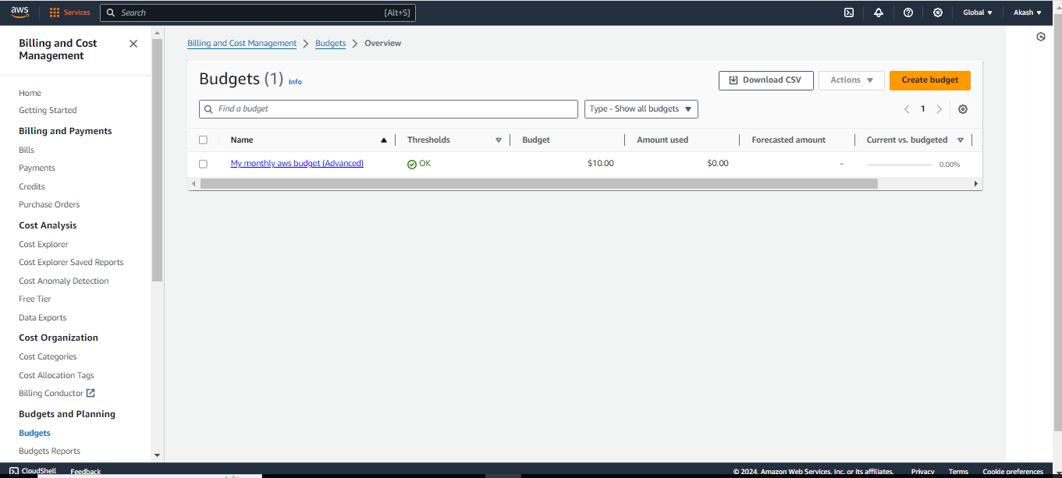

1. Set the Mumbai Regions:

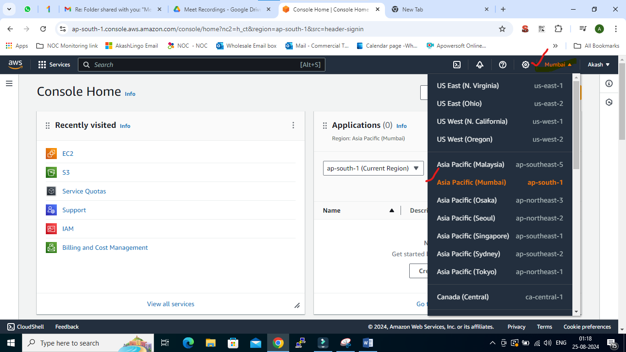

1. Create User

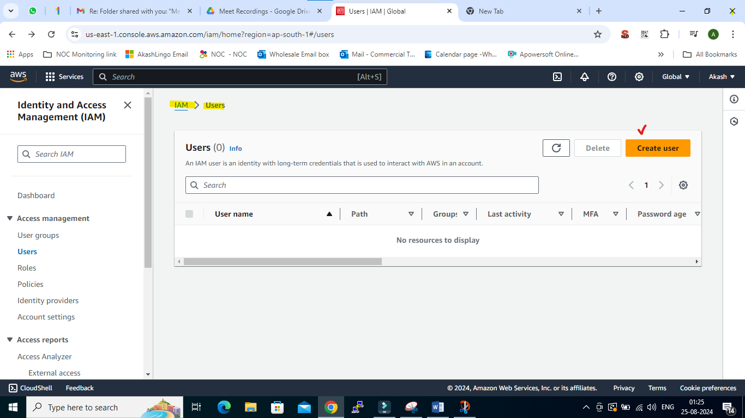

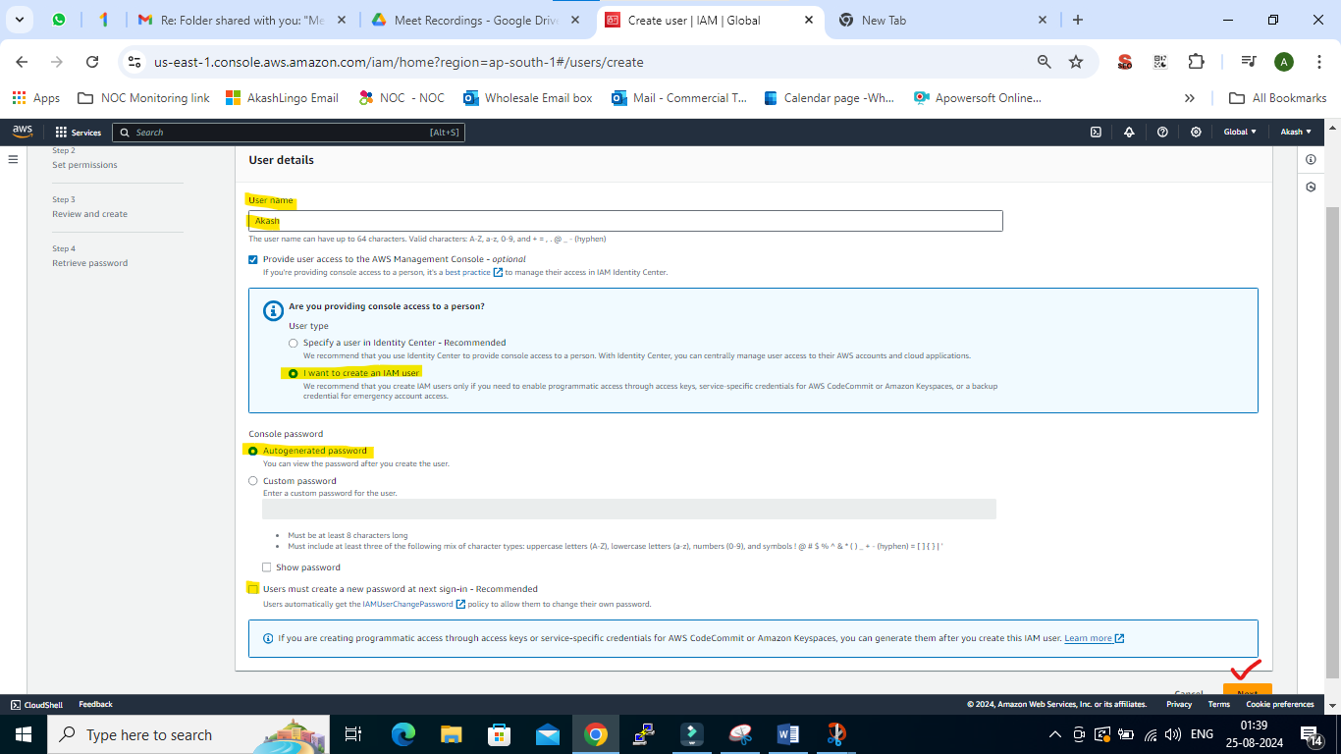

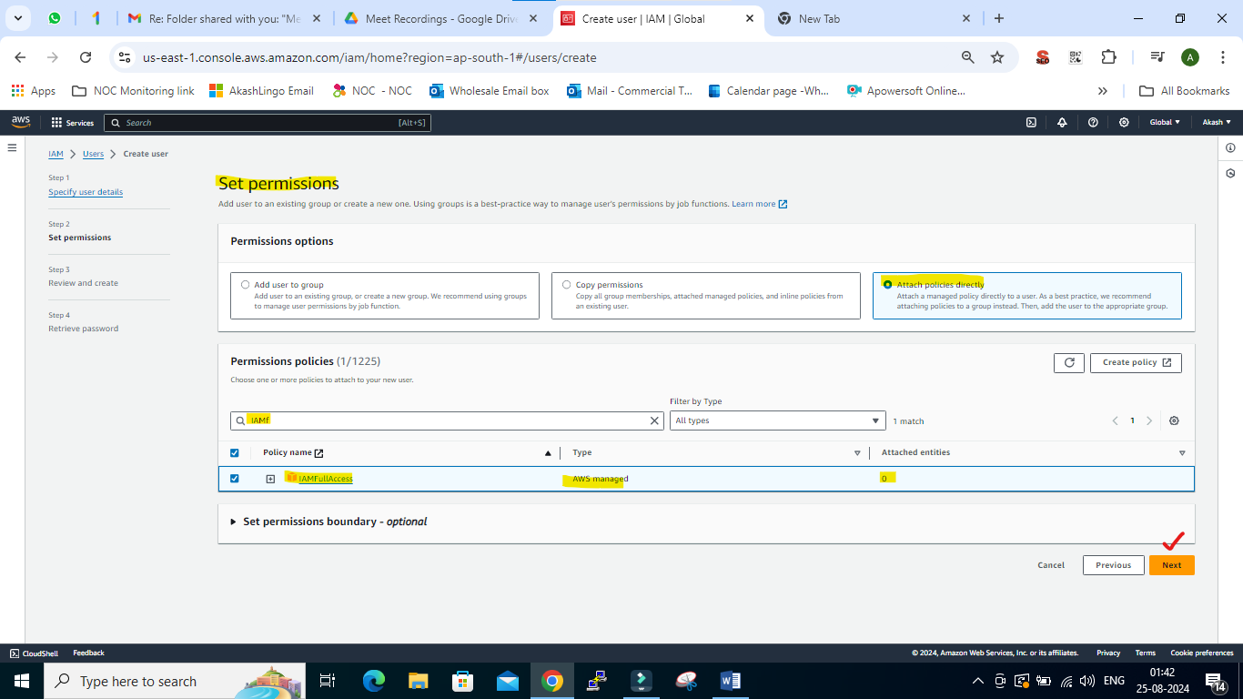

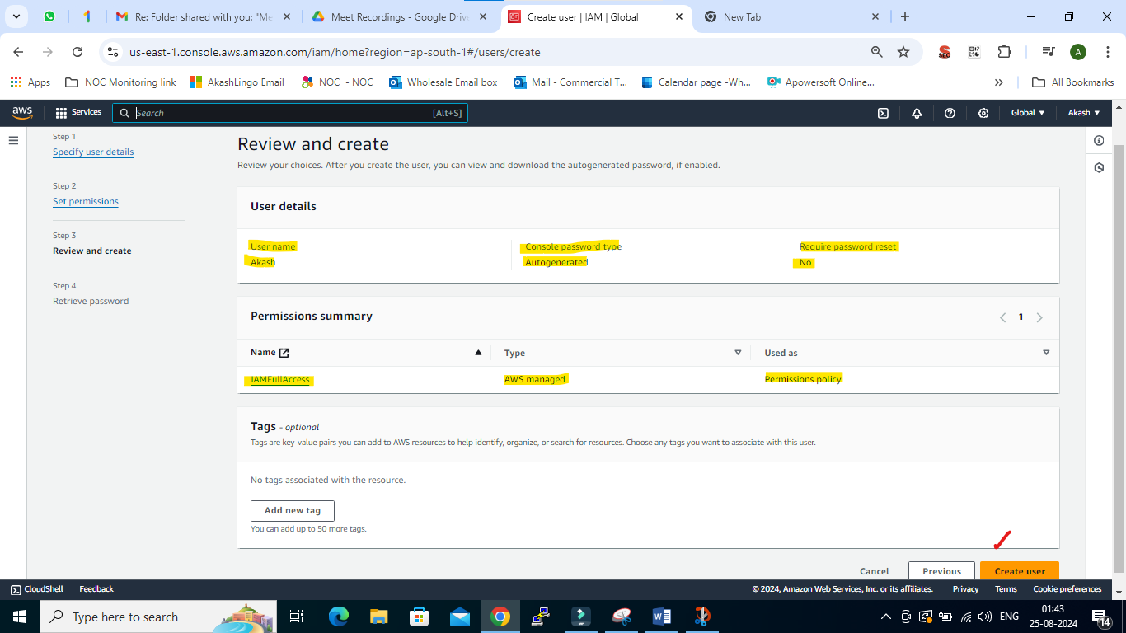

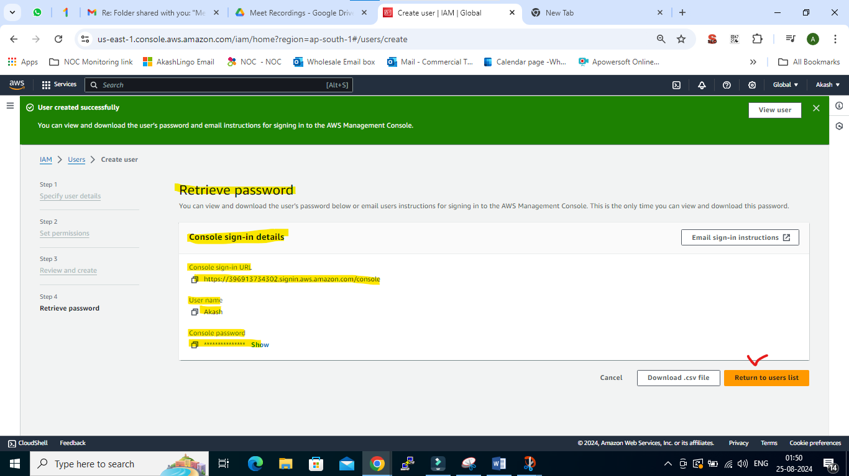

1. Used Different Browser to access IAM user with URL, ID & Password

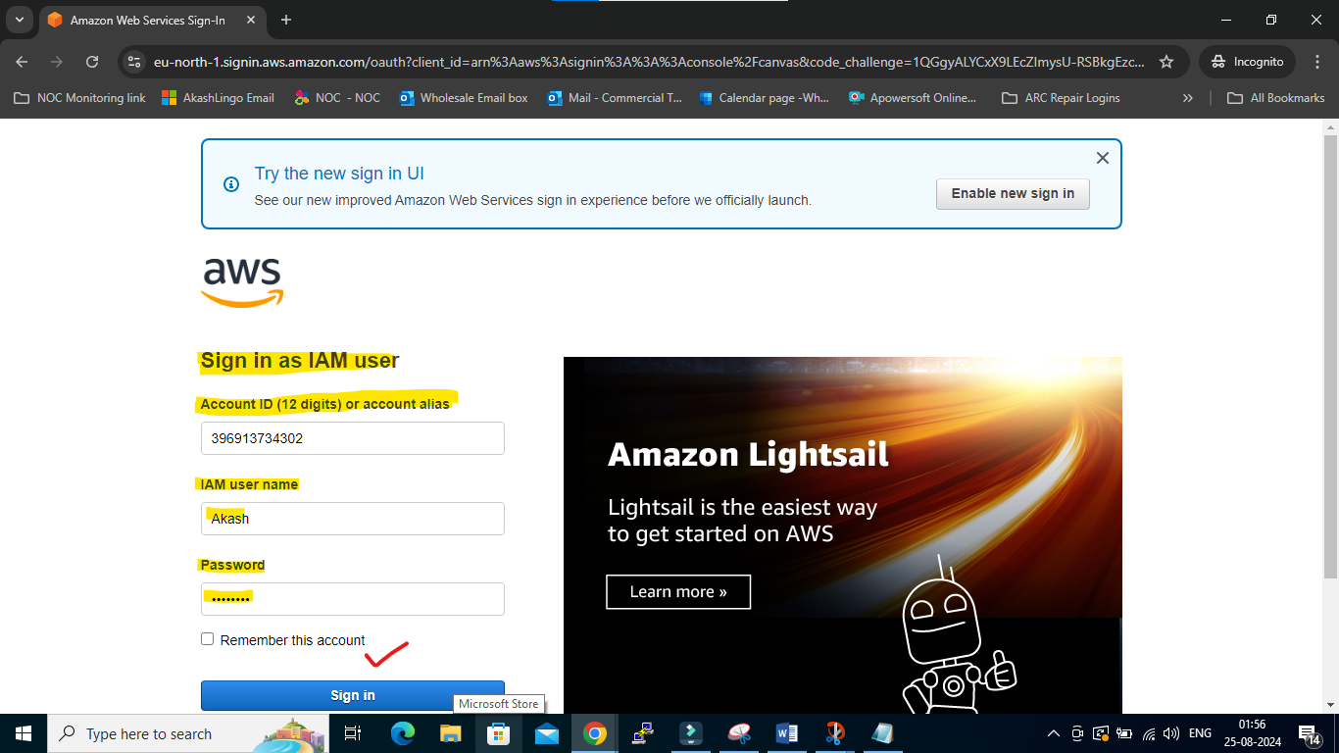

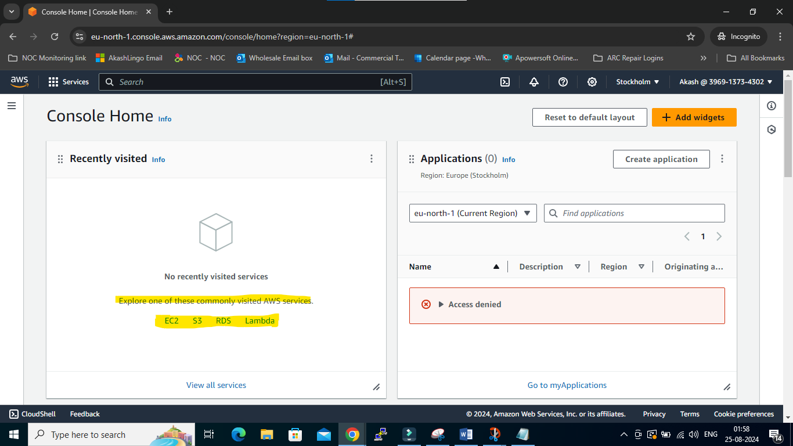

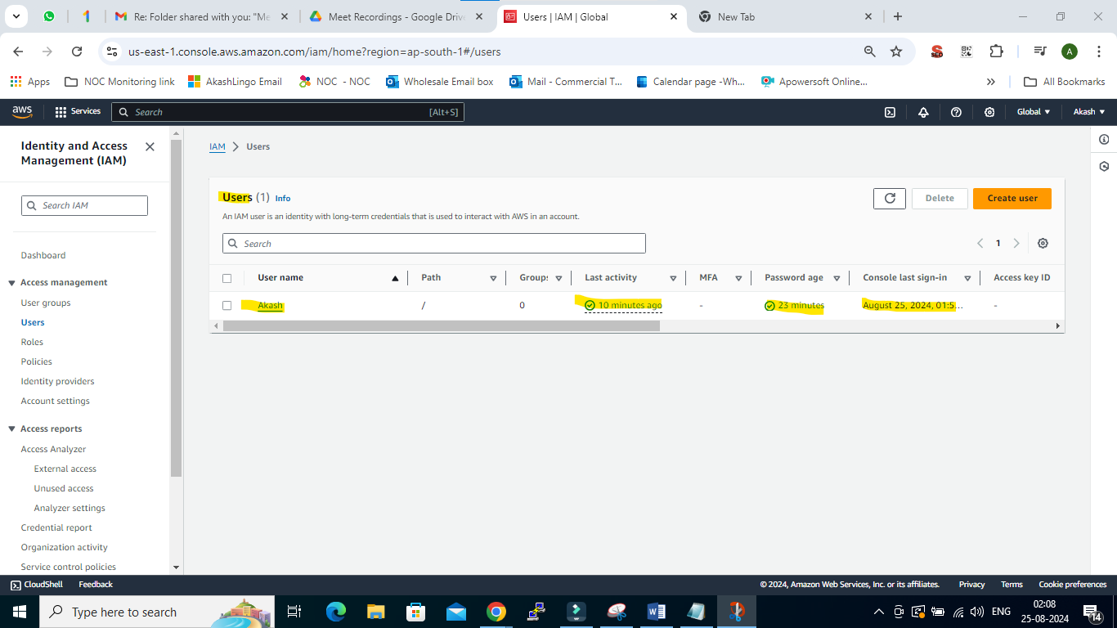

1. IAM User are able to access all the services such as S3 & EC2 etc.

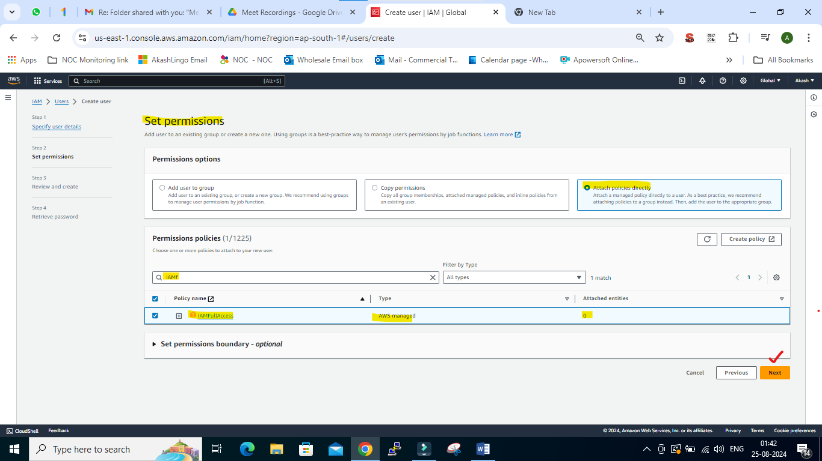

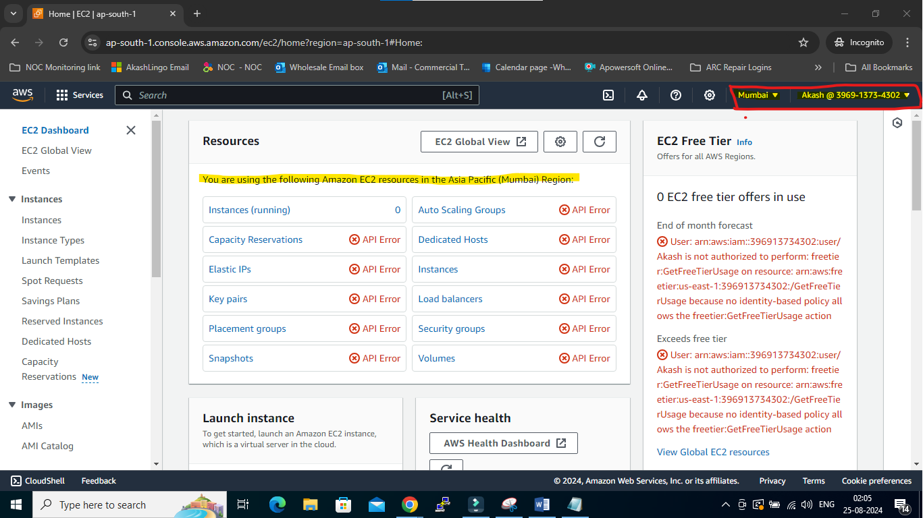

1. User: Airindia >> Policy S3 Full Access:

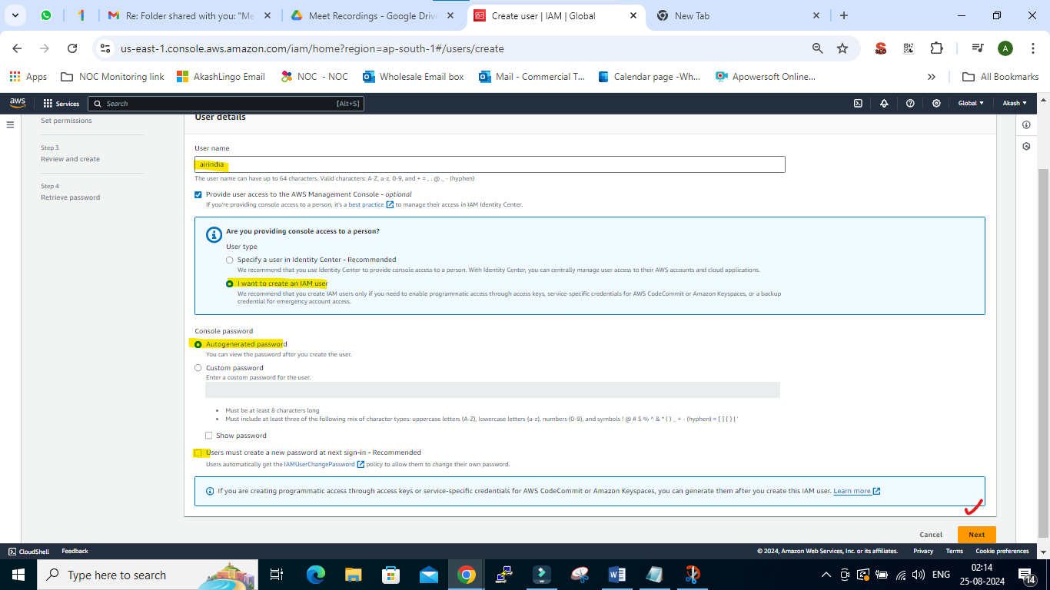

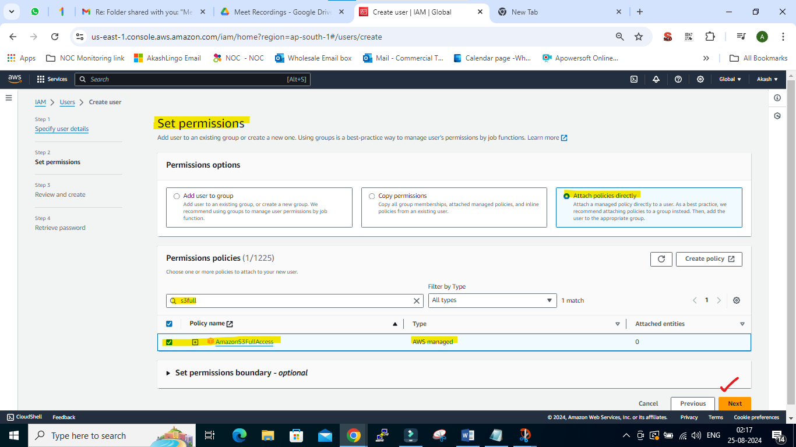

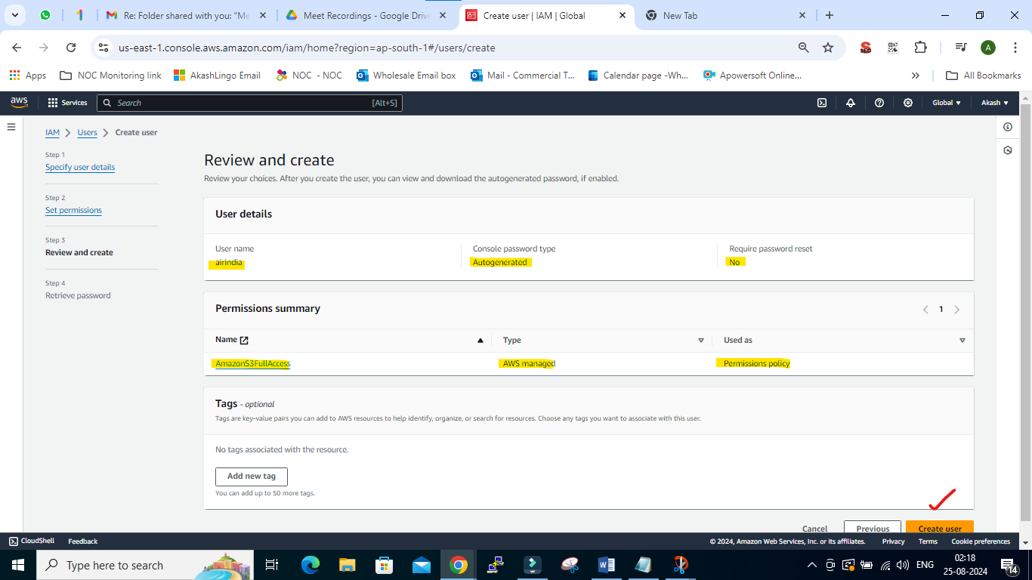

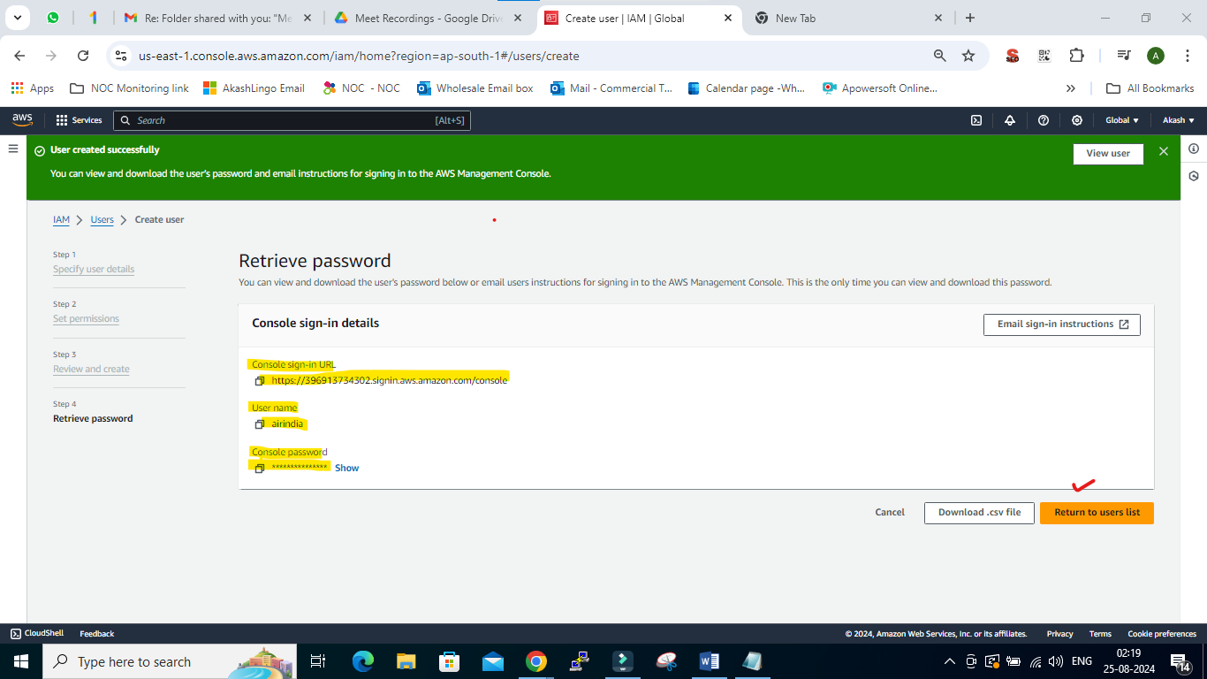

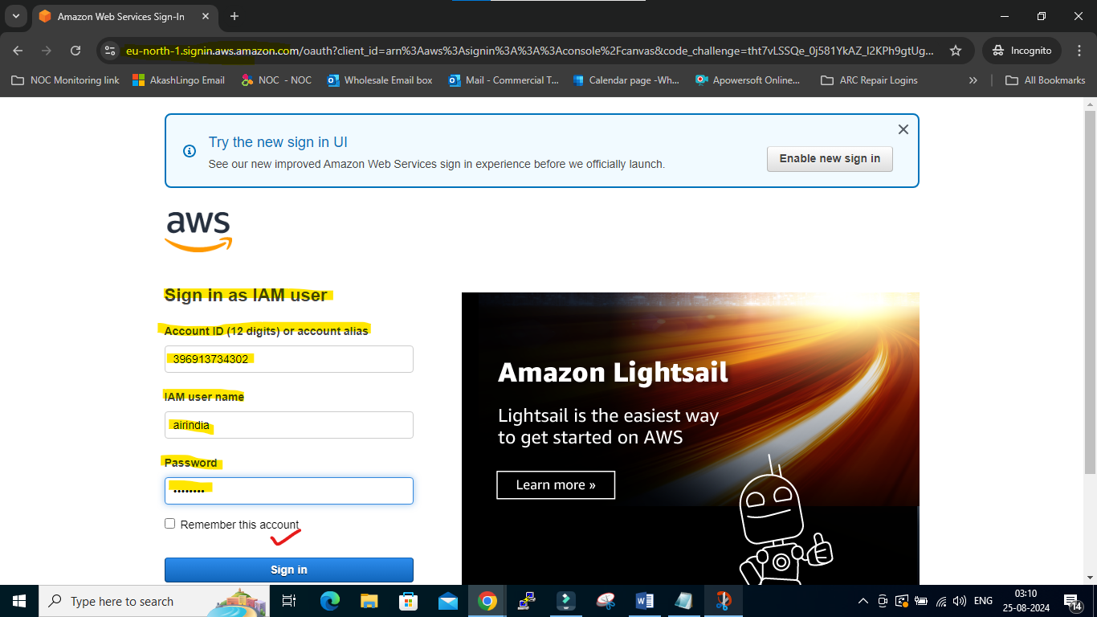

1. AirIndia user is only allow to access S3 not for IAM:

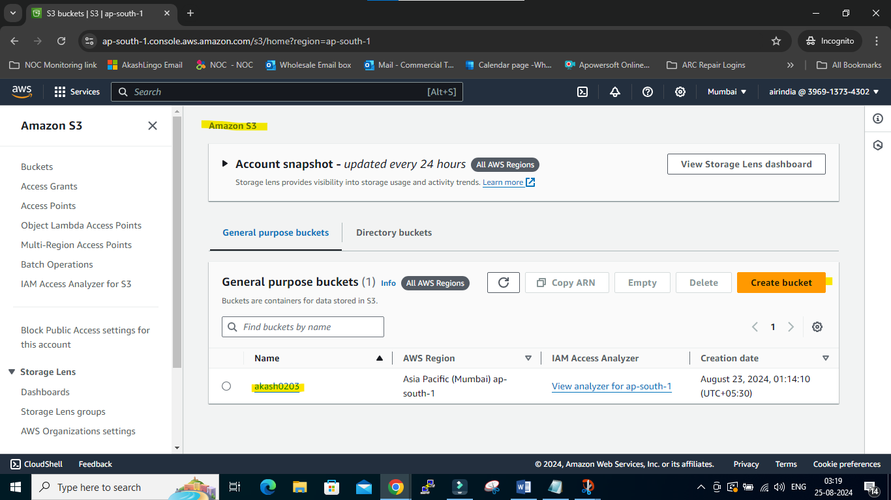

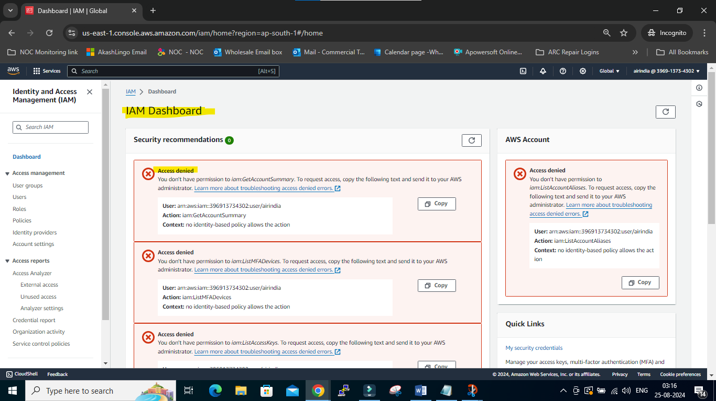

1. Create Groups:

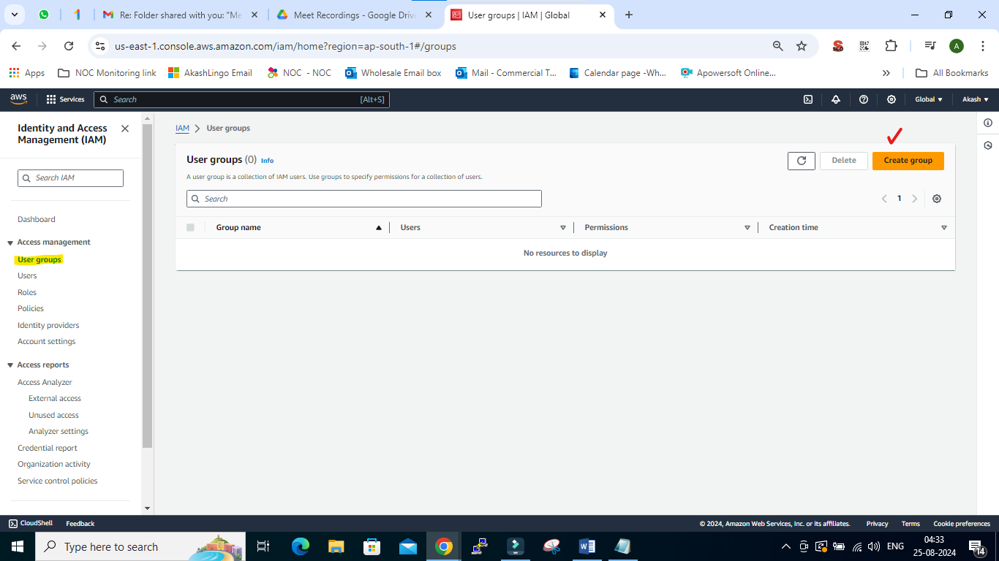

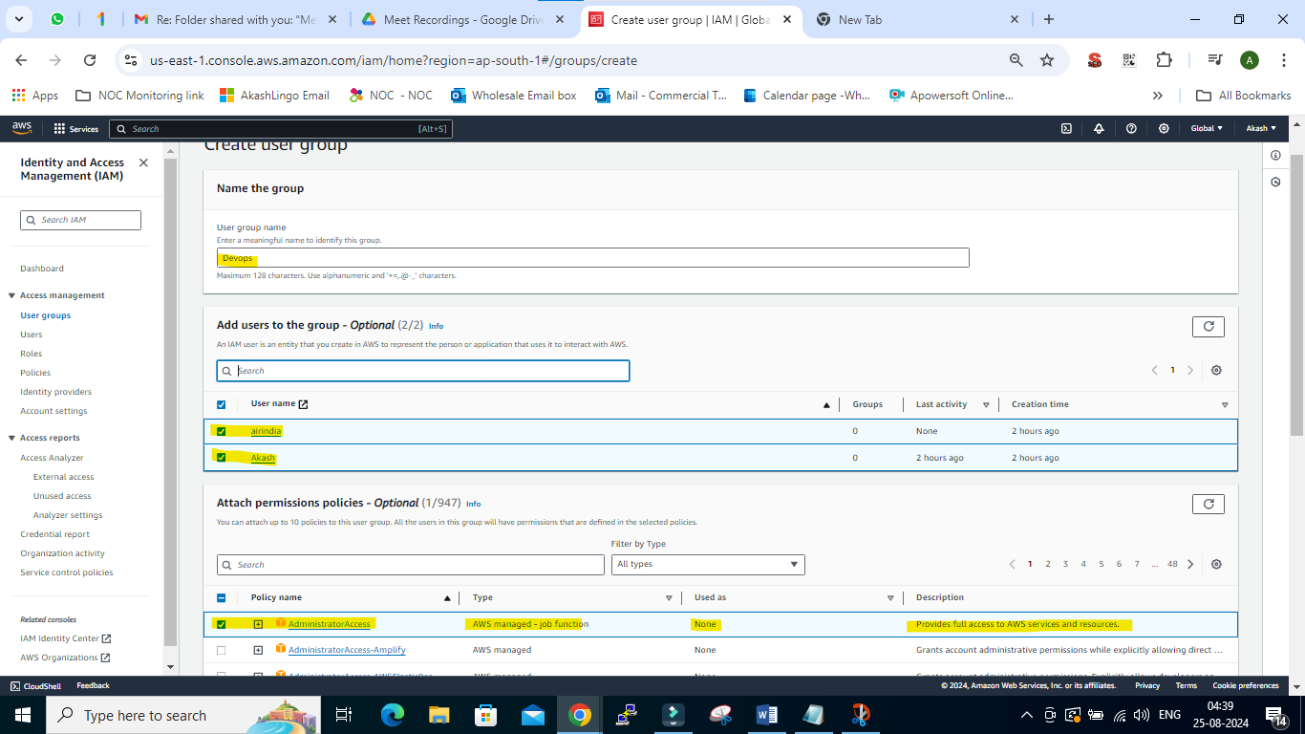

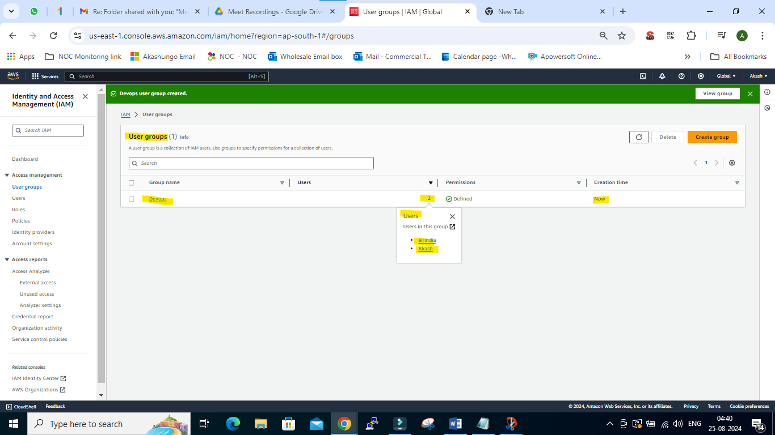

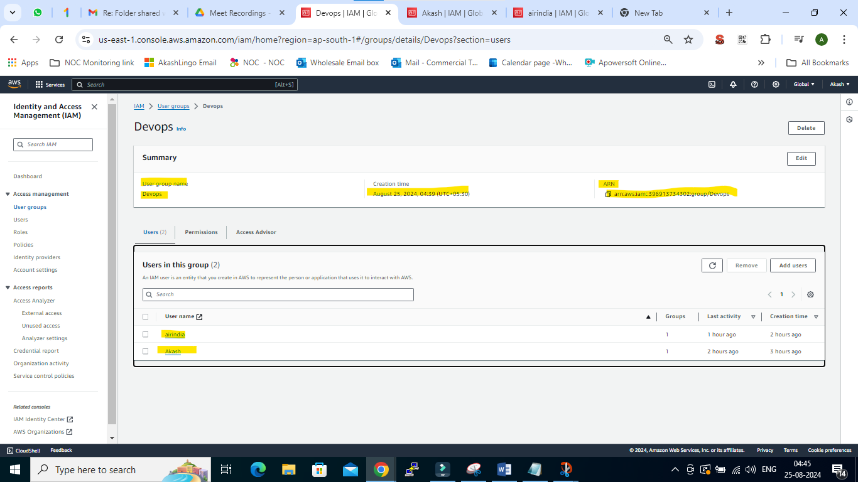

1. Group level permission:

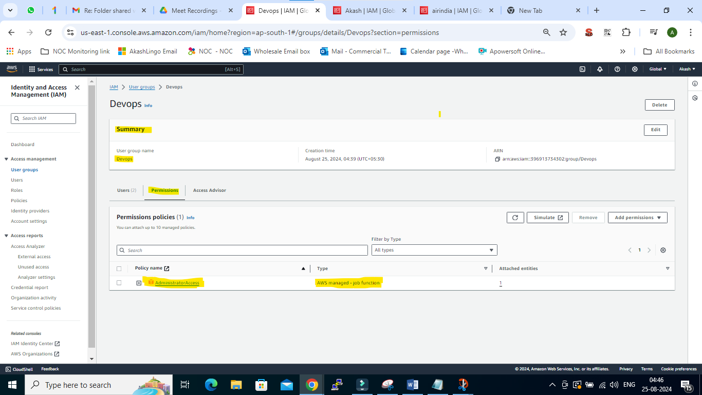

----------------------------------------------------------------------------------------------------------------------------------

1. Individual permissions:

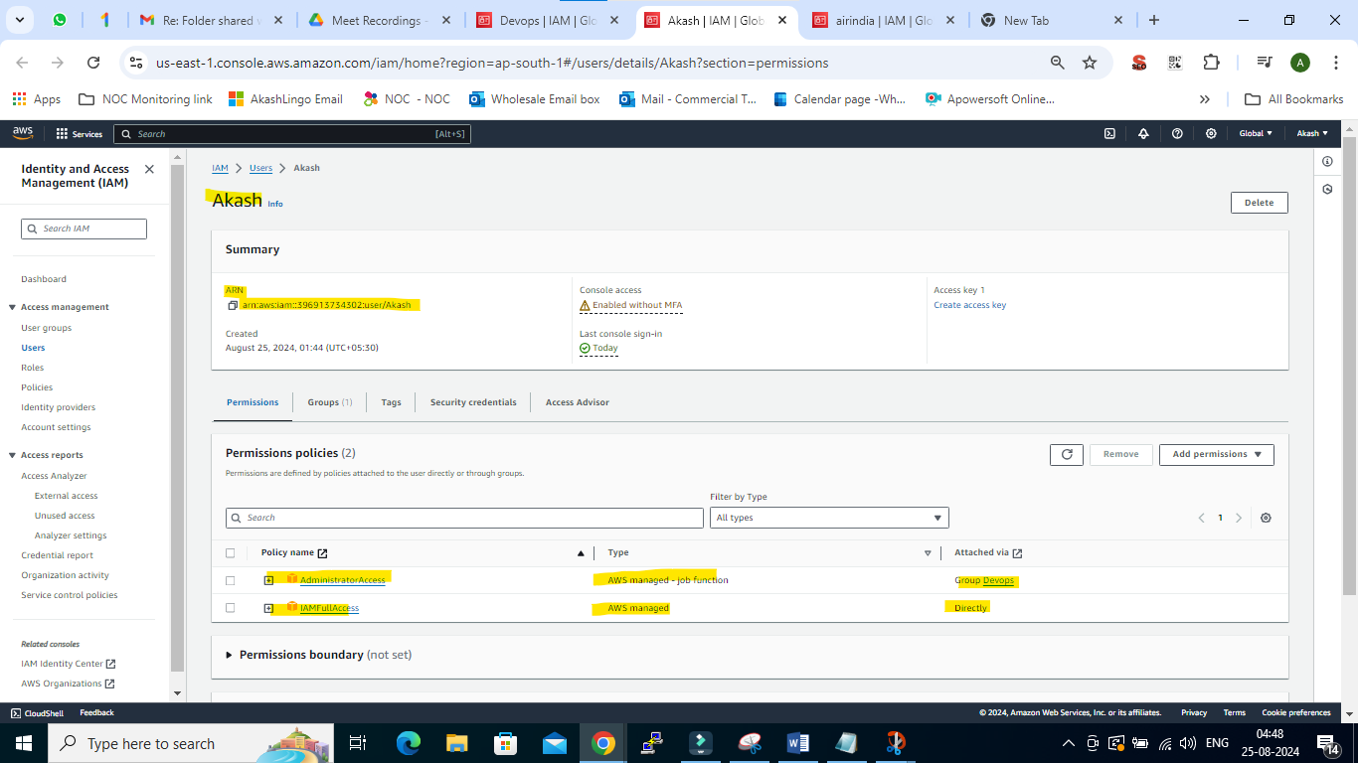

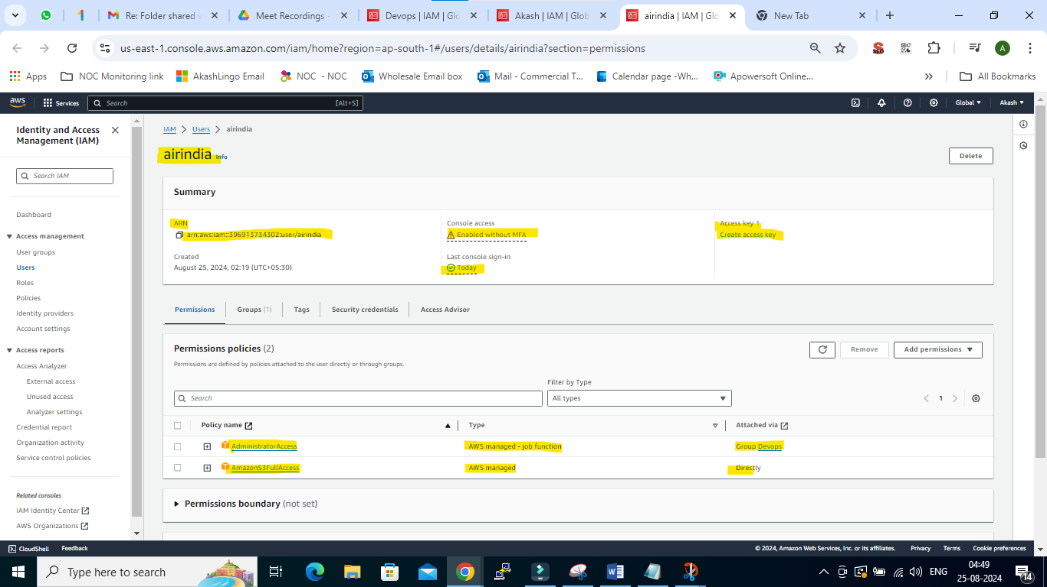

**Access Key & Secret access Key:**

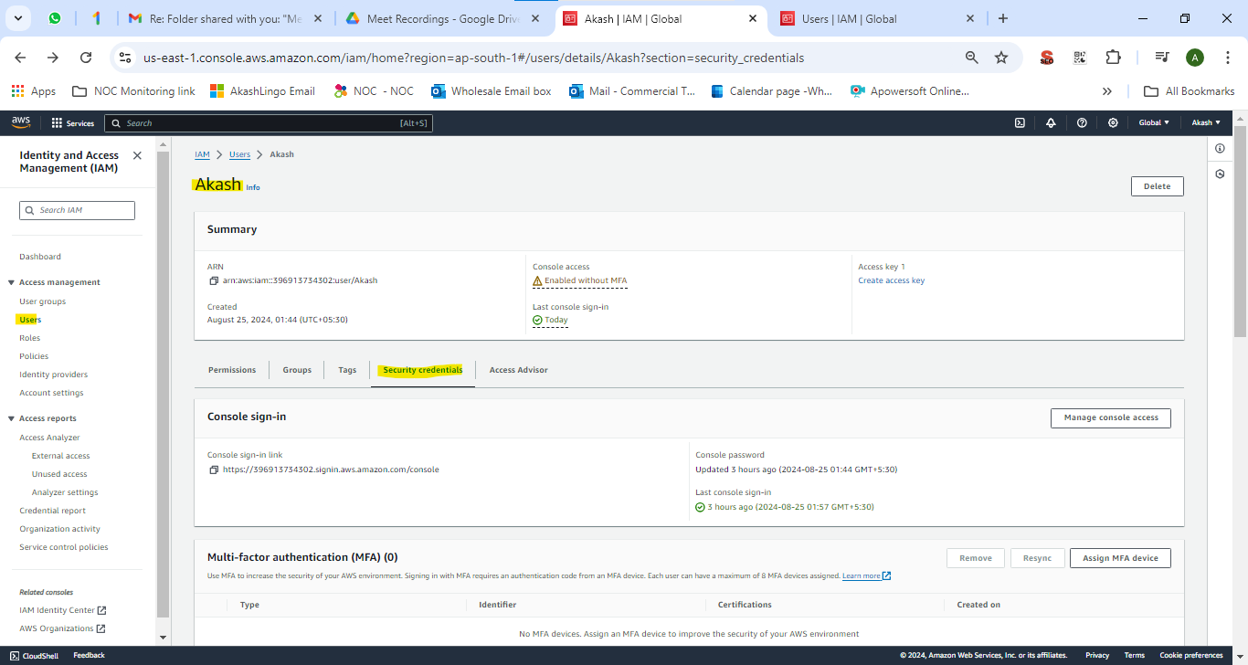

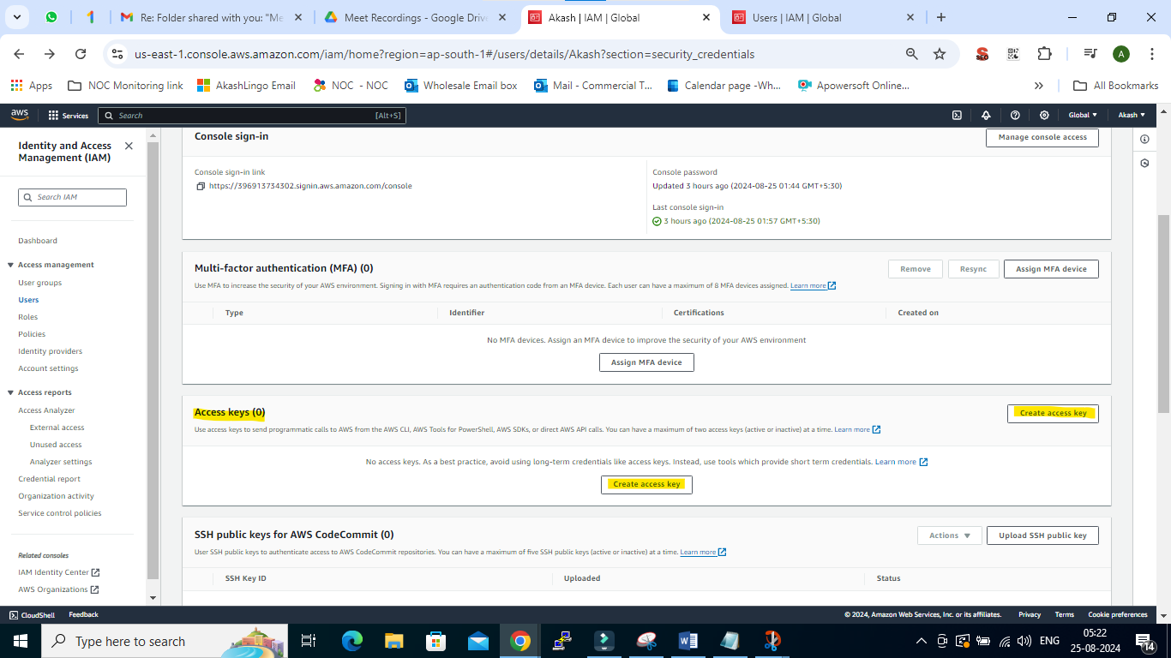

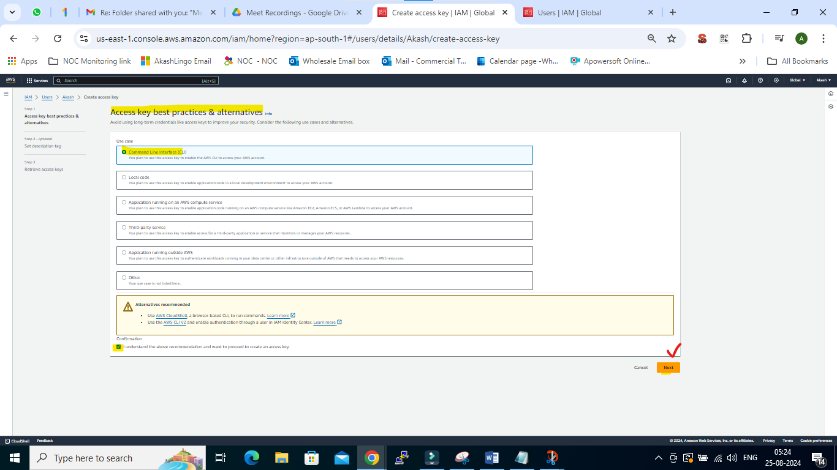

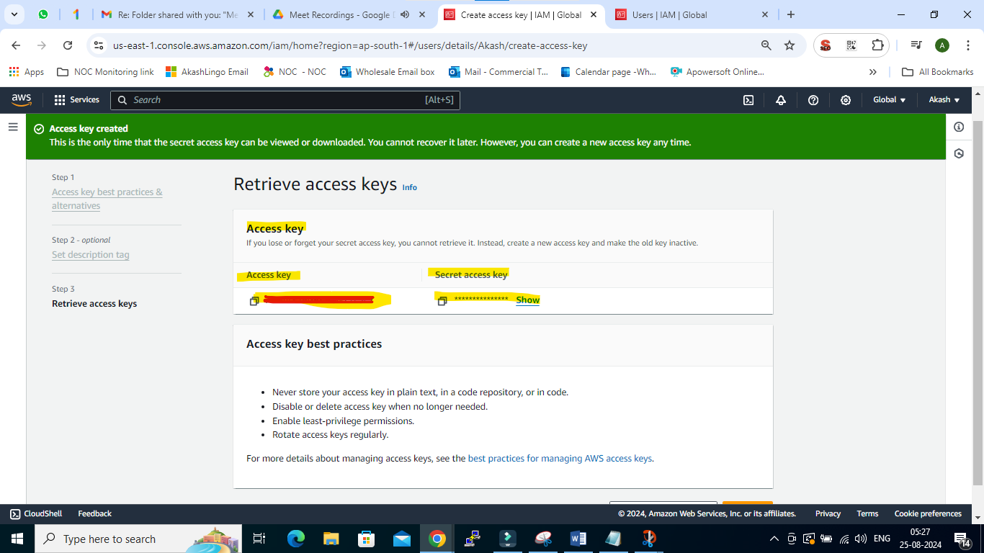

* **By using CLI:**

1. **Create & Deleted User:**

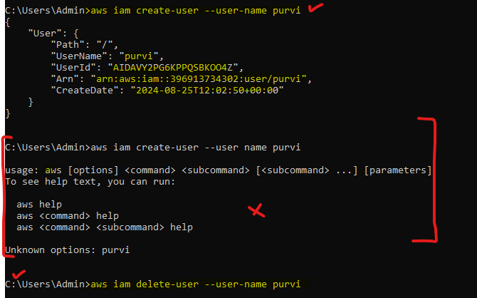

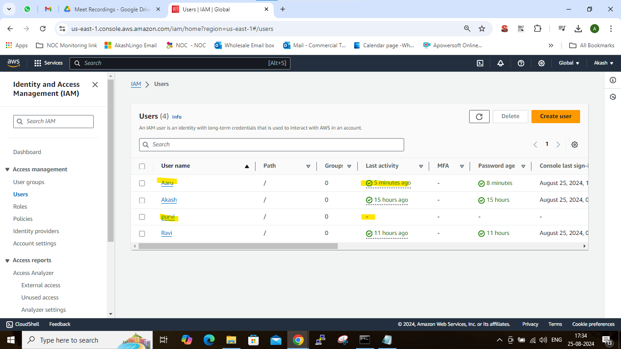

1. **Create & Deleted Group:**

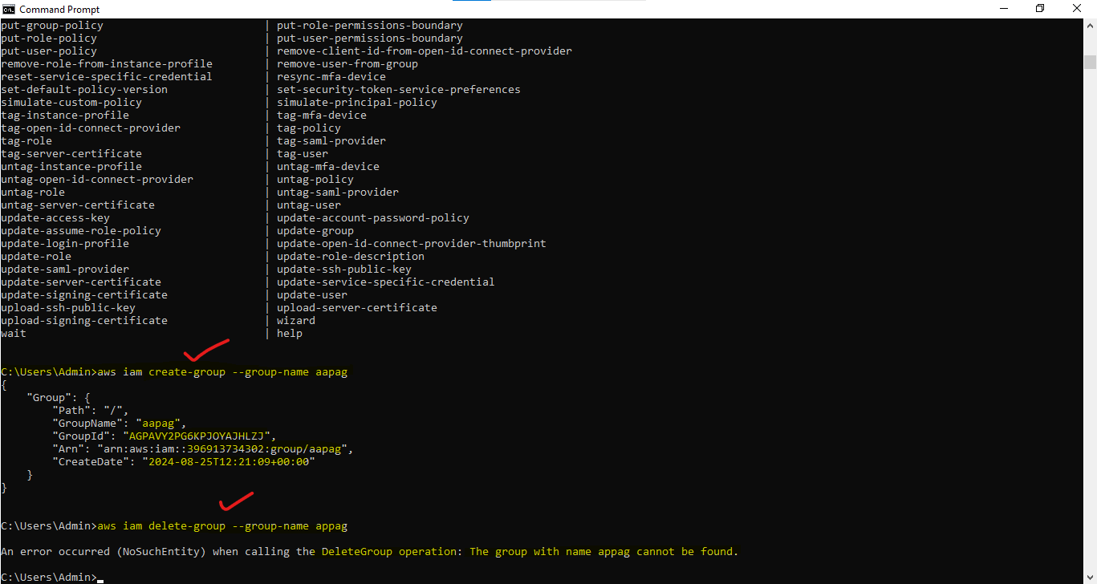

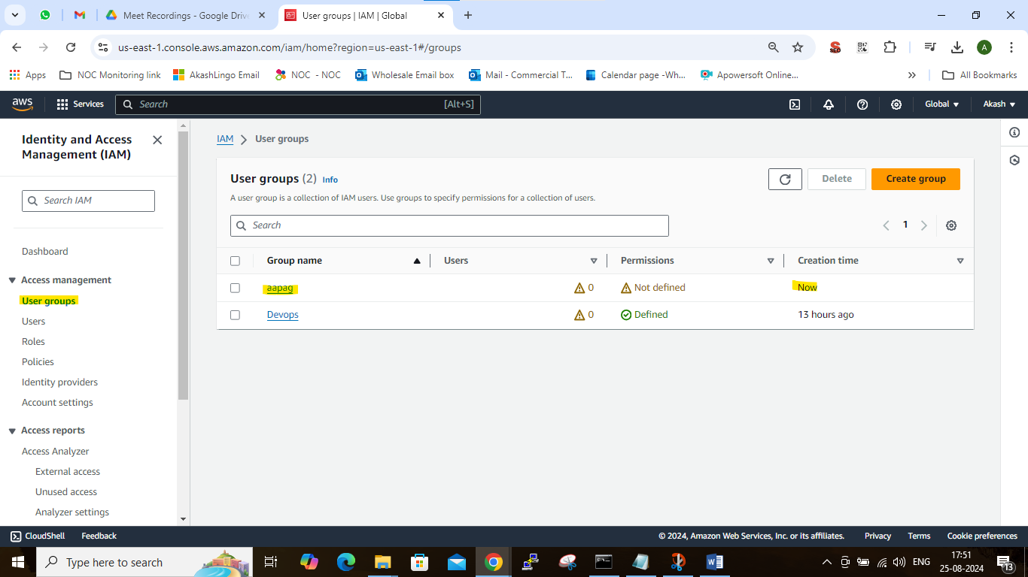

------------------------------------------------------------------------------------------------------------------

**Theory – IAM (Identity Access Management)**

------------------------------------------------------------------------------------------------------------------

**IAM: Identity access management – User management**

IMP: User, Group, Role, Policy Document

* **Login with 3 types**

1. **GUI** – URL, ID, Password
2. **CLI** – Access Key & Secret access key
3. **Terraform -**
4. Create user - Give permission to user – **Policy document** – Writhen in Jason (Java Script Object note- Key value pair) – EC2 Full access
5. Policy Document Type: 1. AWS Managed & 2. Inline Policy
6. While creating user we get ARL (Amazon Record Name) – Unique
7. Ex. **arn:aws:iam::396913734302:user/Akash**
8. Group - Give permission to Group – Policy document – Writhen in **Jason** – EC2 Full access
9. **Role**- assign Policy Document - attached with instance – a) While creating the instance b) Already created in instance

**Q. Why should I learn IAM service?**

IAM is used for the user management with the help of IAM we managed the entire **user management lifecycle**.

* User Management lifecycle

1. User ID Creation / User or Group Creation
2. Password creation
3. Email ID creation
4. Access Management / Policy Document